White Paper – Fluid End Packing Oil
The Impact of Lubricant Quality on Hydraulic Fracturing Fluid End Packing Performance — and How PXP™ SynGLIDE™ 320 Extends Runtime and Reduces Failures

Executive Summary & Introduction
Hydraulic fracturing is one of the most mechanically and thermally demanding applications in the oilfield. At the core of these operations are high-horsepower positive-displacement pumps delivering fracturing fluid into wellbores at 60–120 barrels per minute and treating pressures of 6,000–12,000 psi, with 15,000 psi equipment used for high-pressure stages. This translates to 20,000–60,000+ hydraulic horsepower on location.
The fluid end assembly—containing plungers, liners, and packing assemblies—is the heart of this pumping system. Here, plungers reciprocate hundreds of times per minute through packing assemblies, creating a high-friction, high-temperature, abrasive-laden environment that demands precise sealing and continuous lubrication.
Packing oil in this pass-through lubrication system must simultaneously:
1. Lubricate – Reduce friction between plungers, packing rings, and liners, controlling heat and wear.
2. Protect – Flush abrasive proppant from the sealing interface and form a bonded protective film to prevent frac fluid ingress into metal contact areas.
3. Perform – reduced friction, heat, and vibration, allowing the fluid end operation to improve horsepower, reduce the rate of wear and failure, while extending continuous pumping hours, maximizing operator profits.
When lubricant quality is insufficient—whether from unstable base oils, poor extreme-pressure (EP) chemistry, or weak washout resistance—wear accelerates dramatically. The result is shortened service intervals, increased non-productive time (NPT), and higher total operating cost.
PXP™ SynGLIDE™ 320 is a synthetic ISO VG 320 industrial gear oil engineered exclusively for fluid end packing lubrication in these extreme conditions. Its PXP™ Charged™ cationic EP chemistry magnetically bonds to metal surfaces, providing a persistent protective layer that resists washout, reduces plunger face temperatures by 7–10°F, and shields against abrasion and chemical attack. Field data shows SynGLIDE™ 320 extends continuous pumping hours, reduces packing replacements, and increases plunger and liner service life—delivering measurable ROI for modern frac fleets.

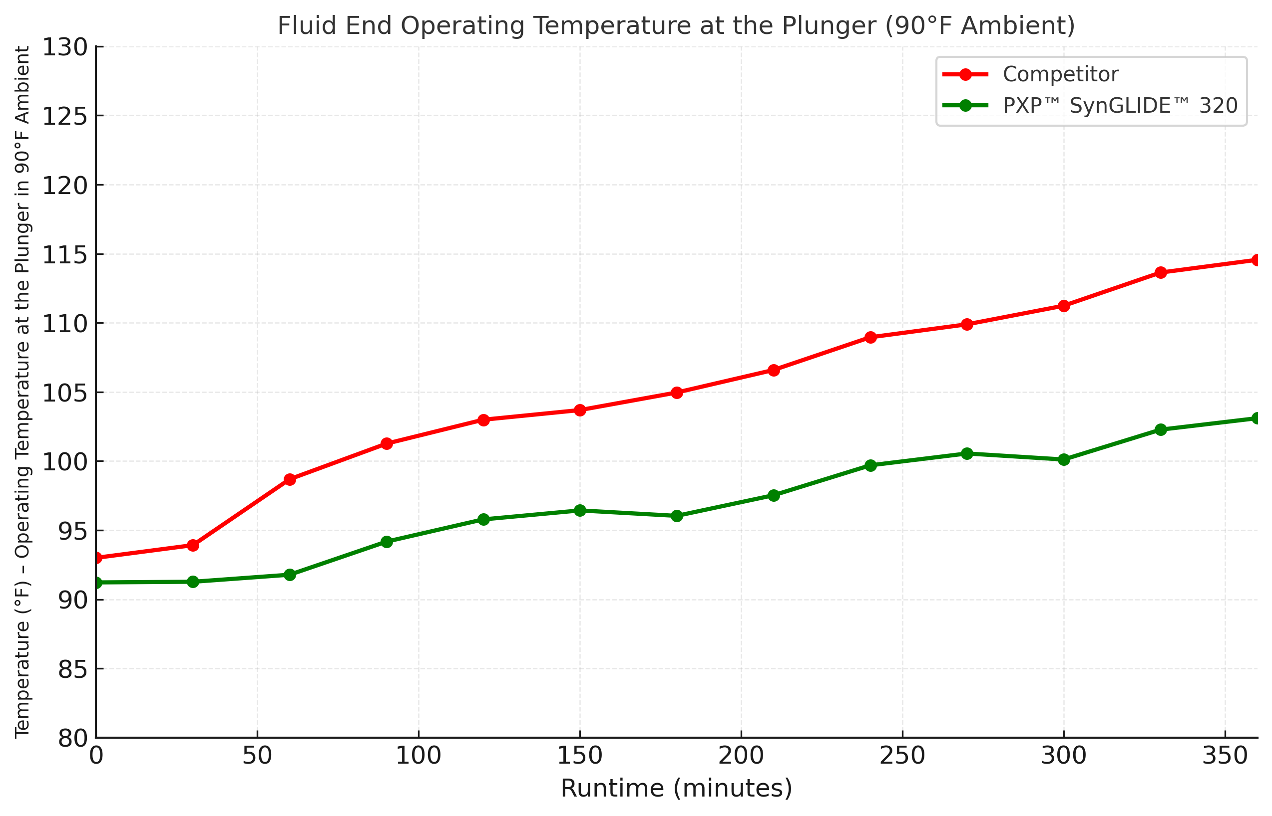

1. The Problems with Insufficient Packing Oil Quality
- Accelerated Packing Wear – Poor-quality oils fail to maintain a boundary film under extreme cyclic loads, allowing direct plunger-to-packing contact. This friction generates heat, hardens packing material, and drastically shortens sealing life.
- Plunger & Liner Scoring – Without robust EP chemistry, metal-to-metal contact occurs during stroke reversals. Abrasive frac fluids infiltrate the lubrication boundary, scoring plungers and liners and reducing sealing efficiency.
- Excessive Heat Generation – Viscosity instability causes oil to thin at high temperature, reducing film strength and increasing friction. The resulting heat feedback loop accelerates wear and increases the risk of blowouts.
- Vibration, Pounding & Misalignment Stress – Inadequate lubrication increases resistance and dynamic loading. This vibration and pounding can damage packing housings, stuffing boxes, and fluid end bores.
- Frequent Maintenance Interruptions – Shorter runtime between packing changes increases NPT, raises labor costs, and exposes sensitive sealing surfaces to environmental contaminants during maintenance.

2. Wear Dynamics in Hydraulic Fracturing Fluid Ends
Hydraulic fracturing fluid ends experience three primary wear points: packing assemblies, plungers, and liners.
Packing Assembly — The First Alarm: Failure Modes include compression fatigue, heat glazing, abrasive washout, and chemical attack. Impact: Visible leaks, reduced pressure control, and frequent downtime.
Plunger — The Fastest to Wear: Failure Modes include direct sliding contact with packing rings, abrasive scoring, and localized “hot bands.” Impact: Often triggers premature packing changes and increases vibration and liner damage.
Liner — Longest Life but Costly to Replace: Failure Modes include abrasive erosion, cavitation pitting, and chemical attack. Impact: Labor-intensive and expensive to replace; damage is often cumulative from plunger and packing failure.
Relative Wear Rates Under Typical Frac Conditions
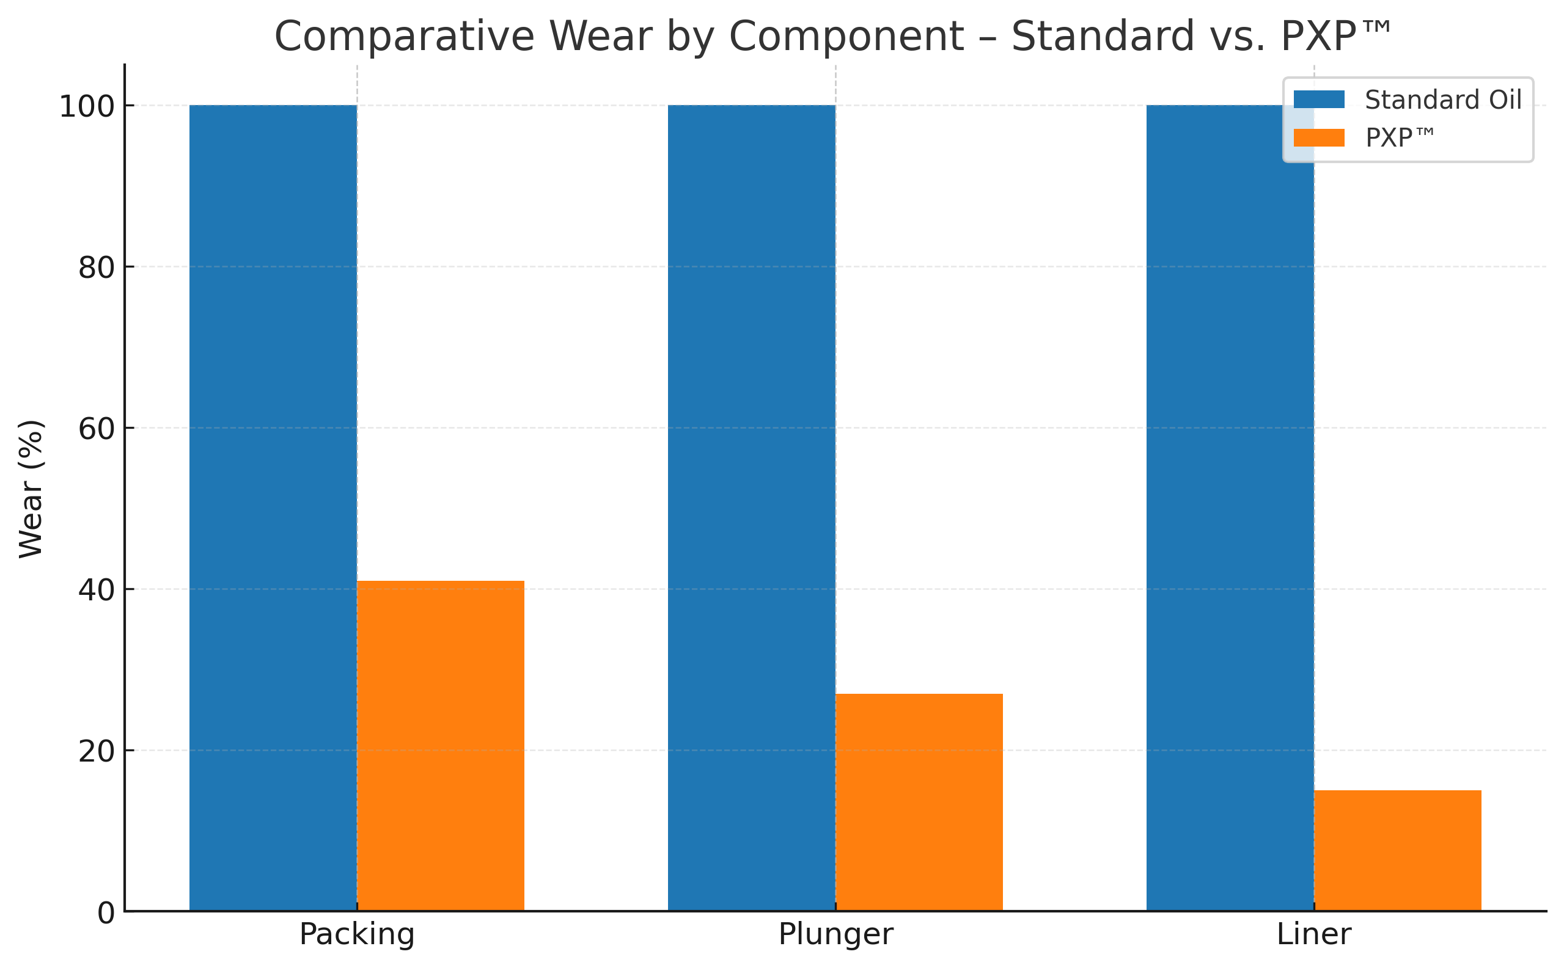

3. The PXP™ SynGLIDE™ 320 Solution
PXP™ Charged™ Cationic EP Chemistry – A positive ionic (+) charge bonds lubricant to negatively charged (-) metal surfaces, creating a persistent lubricating film that resists washout under severe high-pressure shock loads.
Synthetic ISO VG 320 Base Oil Stability – Retains viscosity under high shear and temperature, ensuring film thickness is maintained throughout extended pumping runs.
Abrasive Shielding – Bonded film prevents direct proppant contact with metal surfaces, reducing micro-scoring and wear.

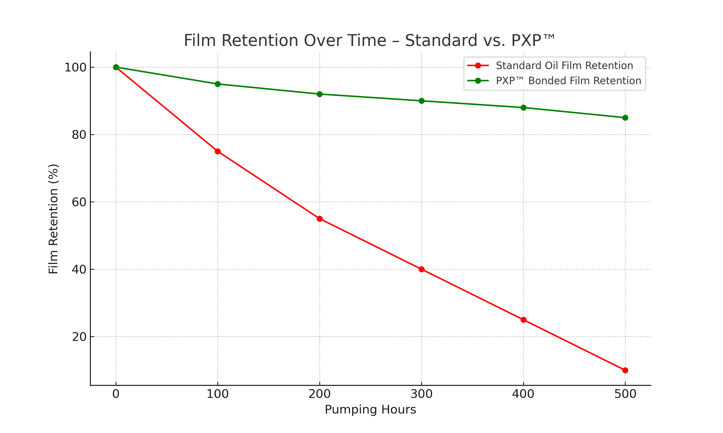

4. Field-Proven Performance Advantages
- 500–700+ continuous pumping hours between packing changes (vs. 250–400 hours for conventional oils)
- Reduced packing replacements lowering labor cost and NPT
- Improved plunger and liner life due to less scoring and erosion
- Lower plunger operating temperatures by 7–10°F
- Reduced vibration and pounding, extending housing and bore life

5. Economic & Operational Impact
- Maintenance cost reduction — fewer packing sets, plungers, and liners replaced
- Increased uptime — more hours between service intervals
- Lower lubricant consumption — extended service life reduces usage volume
- Improved asset utilization — higher productivity per pump in fleet

6. Conclusion
In hydraulic fracturing, fluid end packing lubrication is not a commodity—it is a decisive factor in performance, reliability, and cost control. PXP™ SynGLIDE™ 320 combines cationic EP chemistry, synthetic base oil stability, and abrasive shielding to enable frac fleets to run harder, longer, and with lower total cost of ownership—while protecting the most valuable components in the fluid end assembly.

