Case Study

PXP™ Diesel Engine Oil Outperforms Shell Rotella in Extended Field Trial at Swiftwater Energy

Overview
Permian Production Lubricants conducted a head-to-head performance trial comparing PXP™ 15W-40 Diesel Engine Oil with Shell Rotella 15W-40 in demanding water transfer operations at Swiftwater Energy, a leading provider of pumping services in the Permian Basin.
The trial measured not just operating hours but also quantifiable oil health and wear protection data through third-party ASTM-based oil analysis.

Background
Swiftwater Energy’s diesel-powered pumping equipment operates in extreme oilfield conditions:
- High ambient temperatures and dust exposure
- Continuous-duty cycles exceeding typical OEM recommendations
- Produced water contamination risk
- High-load operation for extended periods
Historically, Shell Rotella 15W-40 was the standard. But rising maintenance costs, frequent oil changes, and elevated wear metals prompted the switch to PXP™ for a performance trial.

Test Parameters
Parameter | Shell Rotella 15W-40 | PXP™ 15W-40 Diesel Engine Oil
Test Duration | 500 hours | 1,000 hours
Analysis Method | ASTM (various methods) | ASTM (same methods)
Engine Type | Diesel-powered pumps | Diesel-powered pumps
Duty Cycle | Continuous load | Continuous load
Location | Permian Basin | Permian Basin

Oil Analysis Results
Metric (ASTM method) | Rotella @ 500 hrs | PXP™ @ 1,000 hrs | Benefit
Viscosity (D445, cSt @100°C) | 13.8 | 15.2 | Higher viscosity stability after double the hours = stronger lubrication film
Copper (ppm) | 59 | 33 | 44% lower = reduced bearing and bushing wear
Molybdenum (ppm) | 180 | 108 | Lower depletion = better retention of anti-wear additive package
Lead (ppm) | 6 | 10 | Slight increase but still very low for double the service hours
Calcium (ppm) | 743 | 1,488 | Double calcium content = stronger detergent/dispersant reserve
Magnesium (ppm) | 838 | 1,038 | Higher detergency and alkalinity support
Phosphorus (ppm) | 1,257 | 718 | Lower phosphorus = reduced catalyst poisoning risk (important for emissions systems)
Barium (ppm) | 1,798 | <1 | Near elimination of barium = less risk of deposit-related failures
TBN (Total Base Number) | 7.93 | 6.61 | Minimal drop despite double hours = excellent acid neutralization retention
Water (ppm) | 29 | 21.1 | Lower moisture contamination = better corrosion control
Oxidation Byproducts (ppm) | 5.6 | 31.7 | Higher but acceptable — natural with longer service life
Sulfation Byproducts (ppm) | 16.5 | 30.7 | Higher due to extended drain but well within safe limits
Nitration Byproducts (ppm) | 5.6 | 10.6 | Higher but proportionally low for double hours, indicating excellent combustion sealing

Explained the Benefits of Analyzing Data
- Viscosity Retention
  - PXP’s viscosity increased slightly over service life, indicating excellent oxidative stability and film strength. Rotella, by comparison, showed greater thinning over half the runtime.
  - Impact: Reduced metal-to-metal contact and extended component life.
- Lower Copper Wear
  - Copper is a key indicator of bushing and bearing wear. PXP cut copper levels by 44%, despite running twice as long.
  - Impact: Longer life for critical rotating components.
- Additive Retention
  - Molybdenum levels remained strong, showing the anti-wear package was still active after 1,000 hours.
  - Impact: Sustained friction reduction over longer drain intervals.
- Higher Detergency (Calcium & Magnesium)
  - PXP retained significantly more detergent/dispersant additives, preventing sludge, varnish, and deposits.
  - Impact: Cleaner engines with fewer hot-spot deposits.
- Reduced Harmful Elements (Barium)
  - PXP showed almost zero barium, lowering the risk of abrasive deposits and fouling.
  - Impact: Improved reliability in extended service.
- Stable TBN
  - Even after double runtime, PXP maintained strong acid-neutralizing capacity (TBN 6.61).
  - Impact: Prevents corrosive wear from acid build-up.
- Lower Water Contamination
  - PXP reduced water ingress compared to Rotella, limiting corrosion potential.
  - Impact: Better long-term seal and bearing protection.
- Controlled Oxidation, Sulfation & Nitration
  - Higher byproducts are expected in extended drains but PXP’s levels remained within safe operational limits.
  - Impact: Confirms oil is still serviceable even after double OEM service life.

Customer Testimonial
"We've seen a 50% reduction in overall oil consumption as the PXP Diesel Engine Oil outlasts the Rotella product by double the running hours. More importantly, the dramatic drop in engine failures and wear has completely changed our approach—we’ve begun purchasing more equipment rather than renting it due to reduced maintenance costs and longer equipment life."
— Edward Carrasco, Maintenance Director, Swiftwater Energy

Charts

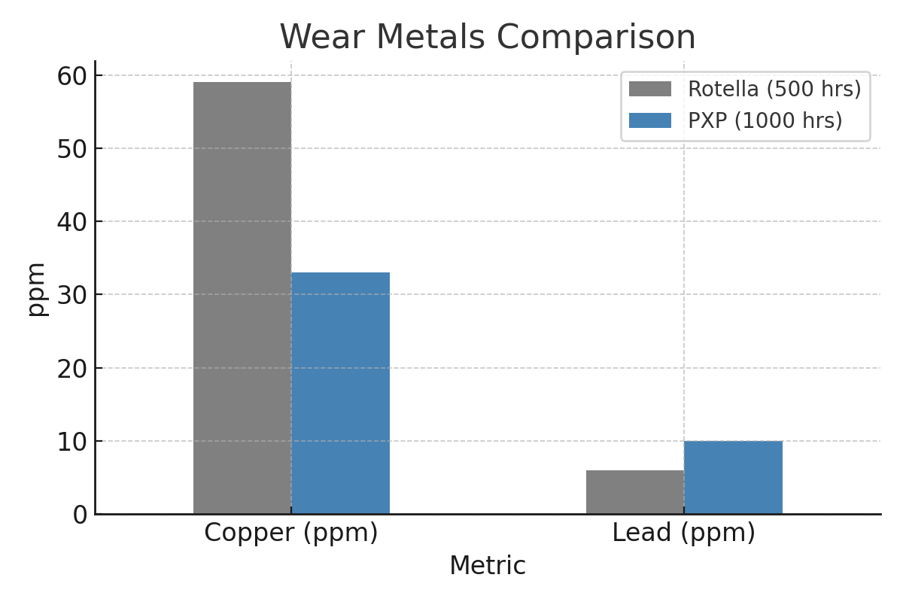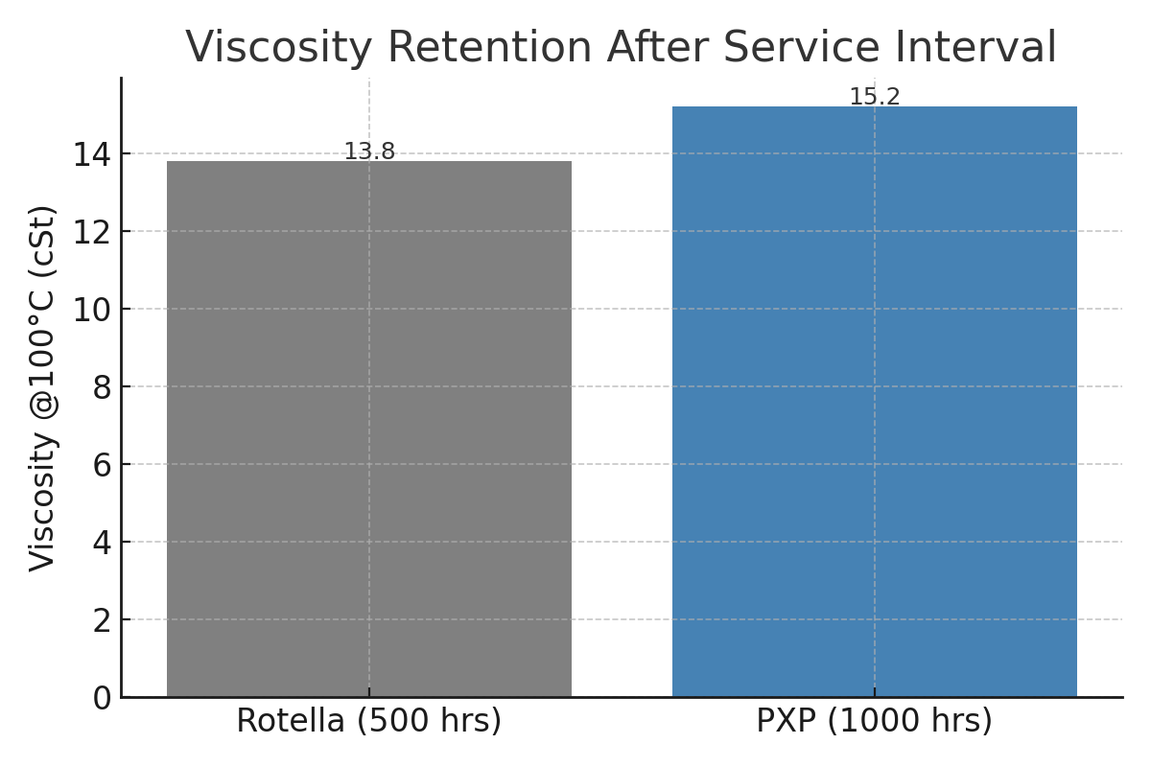

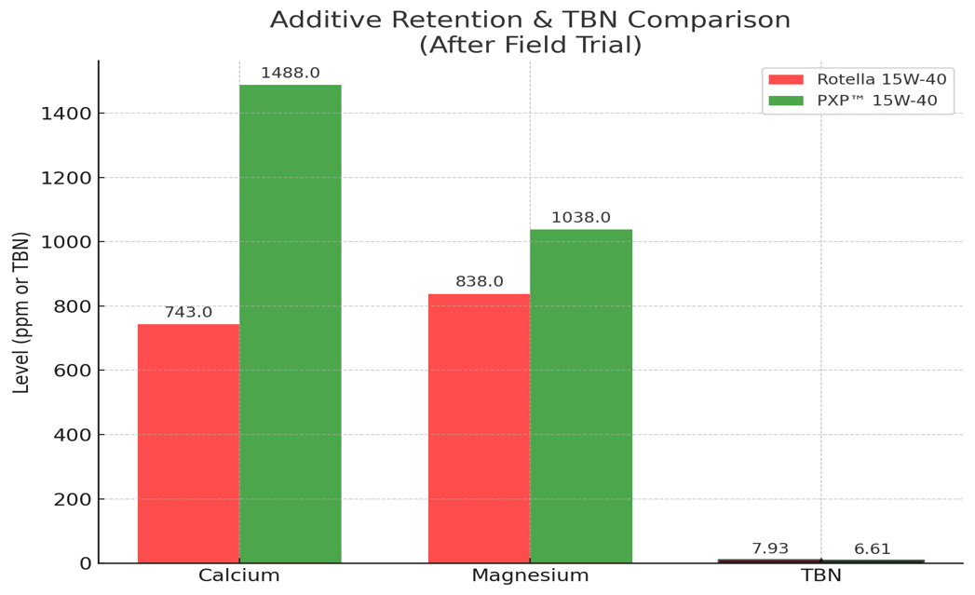

Conclusion
This trial demonstrates that PXP™ 15W-40 Diesel Engine Oil not only extends drain intervals but improves the health of the engine over that extended time. The data clearly shows lower wear metals, stronger additive retention, and superior contamination control compared to Shell Rotella—while running twice as long under the same extreme duty cycle.
PXP’s proprietary base oil technology and advanced dispersant package give operators the performance edge needed in high-load, high-contamination environments like the Permian Basin.
n this kind of oil analysis, lower levels of oxidation, sulfation, and nitration byproducts are generally considered better — but the interpretation depends heavily on:
- Service hours / drain interval
- Operating environment
- Engine design and fuel type

The Test Results – What They Mean and How They Impact Engines

Oxidation Byproducts
- What it means: Oxidation is the chemical reaction of oil with oxygen, accelerated by heat and contaminants. It thickens the oil, forms varnish, and depletes additives.
- Better: Lower values — indicate the oil hasn’t degraded as much.
- Your Data:
  - Rotella (500 hrs): 5.6 ppm
  - PXP (1,000 hrs): 31.7 ppm
  - PXP’s oxidation is higher, but it’s proportional to double the runtime and still in a healthy range for in-service oil.
- Interpretation: The rise is expected with extended drain intervals. Since viscosity stayed in spec and TBN was still strong, the oil was still serviceable.

Sulfation Byproducts
- What it means: Sulfation results from combustion byproducts (mainly sulfur compounds from fuel) combining with water and heat, forming acids.
- Better: Lower values — less acid formation means less corrosion risk.
- Your Data:
  - Rotella (500 hrs): 16.5 ppm
  - PXP (1,000 hrs): 30.7 ppm
  - PXP’s sulfation is higher, but again this is in proportion to service time and still not at harmful levels.
- Interpretation: Detergents (calcium/magnesium) and TBN kept acids neutralized, preventing damage.

Nitration Byproducts
- What it means: Nitration is caused by the reaction of oil with nitrogen oxides from combustion — worsens with high loads and high combustion temps. Leads to oil thickening and deposits.
- Better: Lower values — indicates less exposure to blow-by gases or high-temp nitration.
- Your Data:
  - Rotella (500 hrs): 5.6 ppm
  - PXP (1,000 hrs): 10.6 ppm
  - Increase is expected for the longer run, but PXP’s rate of increase is modest, indicating excellent resistance to nitration.

Key Takeaway for this Case Study
In the trial, PXP ran twice as long, so naturally, oxidation, sulfation, and nitration values rose compared to Rotella’s shorter test.
However:
- All values stayed within safe, operational limits.
- Additive levels (calcium, magnesium, TBN) remained sufficient to neutralize acids and control deposits.
- No signs of oil thickening beyond spec (viscosity remained excellent).
This is a proof point:
PXP handled double the runtime without reaching the wear or contamination limits that would require an oil change — something Rotella could not match.

Interpretation of Oil Analysis Data
Metric | What It Measures | Better: Higher or Lower? | Data & Interpretation
Viscosity (ASTM D445, cSt @100°C) | Thickness of oil film at operating temp — key to maintaining separation between moving parts. | For used oil, stability is key — too low = loss of protection, too high = deposits or oxidation. | Rotella: 13.8 (thinning after 500 hrs) vs PXP: 15.2 (slightly thicker after 1,000 hrs). PXP retained viscosity better, meaning it still had strong film strength after double runtime.
Copper (ppm) | Wear from bronze/brass components (bearings, bushings, coolers). | Lower is better. | Rotella: 59 ppm vs PXP: 33 ppm — 44% less wear despite double service time. Shows superior anti-wear film protection.
Molybdenum (ppm) | Anti-wear and friction-modifying additive. | Higher retention is better. | Rotella: 180 ppm vs PXP: 108 ppm — PXP still retained significant moly after twice the hours, showing additive longevity.
Lead (ppm) | Wear from bearings or lead-based solder in cooler components. | Lower is better. | Rotella: 6 ppm vs PXP: 10 ppm — Slightly higher for PXP but still extremely low considering double runtime. No cause for concern.
Calcium (ppm) | Primary detergent/dispersant additive for controlling deposits and neutralizing acids. | Higher retention is better. | Rotella: 743 ppm vs PXP: 1,488 ppm — Double the reserve in PXP, indicating stronger acid control and cleaner internals.
Magnesium (ppm) | Secondary detergent/dispersant — also buffers acids. | Higher is better (for detergent capacity). | Rotella: 838 ppm vs PXP: 1,038 ppm — PXP maintained higher detergent levels for longer-lasting cleanliness.
Phosphorus (ppm) | Anti-wear additive, part of ZDDP chemistry. | Adequate levels needed, but too high can harm catalytic systems. | Rotella: 1,257 ppm vs PXP: 718 ppm — PXP used a balanced phosphorus load for wear control while reducing catalyst-poisoning risk.
Barium (ppm) | From certain detergent or corrosion inhibitor packages — can cause deposits. | Lower is better. | Rotella: 1,798 ppm vs PXP: <1 ppm — PXP virtually eliminated barium, reducing deposit risk.
TBN (Total Base Number) | Oil’s reserve alkalinity — ability to neutralize acids. | Higher retention is better. | Rotella: 7.93 vs PXP: 6.61 — PXP had strong acid neutralizing reserve after twice the hours, indicating better long-term protection.
Water (ppm) | Contamination from condensation or produced water ingress. | Lower is better. | Rotella: 29 ppm vs PXP: 21.1 ppm — PXP had lower water content, reducing corrosion potential.
Oxidation Byproducts | Chemical degradation from oxygen + heat. | Lower is better. | Rotella: 5.6 ppm vs PXP: 31.7 ppm — Increase is expected with extended drain; still within safe range.
Sulfation Byproducts | Combustion-derived acids from fuel sulfur. | Lower is better. | Rotella: 16.5 ppm vs PXP: 30.7 ppm — Expected rise with more hours but less ppm per 500 hour interval, and still controlled by strong detergent package.
Nitration Byproducts | Reaction with nitrogen oxides from combustion gases. | Lower is better. | Rotella: 5.6 ppm vs PXP: 10.6 ppm — Slight increase, proportional to runtime; less ppm per 500 interval, indicates good resistance to blow-by contamination.

Big-Picture Takeaways
- Wear Metals: PXP dramatically reduced copper wear — the most telling sign of better bearing/bushing life.
- Additive Retention: Calcium, magnesium, and TBN retention confirm PXP’s dispersant and acid-neutralizing systems stay effective longer.
- Contamination Control: Lower water and barium show PXP resists harmful contamination better than Rotella.
- Service Life: Even after twice the runtime, PXP’s byproduct levels (oxidation, sulfation, nitration) were within safe limits — proving extended drain capability.
- Operational Advantage: These results translate to less downtime, fewer oil changes, reduced wear, and longer engine life — exactly what operators want in the field.

