Technical White Paper: PXP™ Low Ash NGEO in Extended Drain, High-Heat, Continuous Duty Sour Gas Operation

Executive Summary & Introduction
Natural gas compressor engines in sour gas service operate under some of the harshest mechanical, thermal, and chemical conditions in the oil and gas industry. High cylinder temperatures, elevated combustion chamber pressures, continuous duty cycles, and the corrosive effects of hydrogen sulfide (H₂S) demand lubricants that can retain viscosity, neutralize acids, and protect critical wear surfaces over long drain intervals. Inadequate lubrication in this environment leads to rapid wear, loss of efficiency, and costly unplanned downtime.
Permian Production Lubricants’ PXP™ Low Ash NGEO is engineered with proprietary PXP™ Charged™ technology, synthetic base oil stability, and an advanced dispersant package that addresses the root causes of lubricant failure in these severe-duty applications. Field and lab data confirm measurable improvements in viscosity retention, total base number (TBN) stability, and wear metal reduction compared to conventional industry lubricants.

1. Common Lubrication Problems in Extended Drain Sour Gas Operation
1.1 Viscosity Breakdown
Conventional low ash NGEOs suffer from viscosity loss due to oxidative and thermal degradation over time, especially in high-load, high-temperature environments. This thinning compromises oil film thickness, allowing metal-to-metal contact.
1.2 Acid Build-up from H₂S
Sour gas contains hydrogen sulfide, which produces sulfuric acid during combustion. Without sufficient base reserve (TBN), these acids attack metal surfaces, causing corrosive wear and component pitting.
1.3 Accelerated Wear Metal Generation
Iron from liners and copper from bearings accumulate faster in inadequate lubricants due to poor film strength, high acidity, and abrasive particulate ingress.
1.4 Additive Depletion
In extended drain cycles, detergents, dispersants, and anti-wear agents are depleted. Once these protective additives are consumed, deposits form and wear rates rise sharply.

2. How PXP™ Low Ash NGEO Addresses These Challenges
2.1 PXP™ Charged™ Technology
Our proprietary cationic extreme pressure (EP) chemistry creates a positively charged lubricant film that bonds electrostatically to negatively charged metal surfaces. This ensures persistent boundary lubrication even under high washout conditions.
2.2 Synthetic Base Oil Stability
The synthetic ISO base oil maintains viscosity within a narrow band, resisting oxidative thickening and thermal thinning — ensuring strong film integrity over thousands of hours.
2.3 Advanced Acid Neutralization
A fortified low-ash detergent and dispersant package provides superior acid neutralization, with TBN retention up to 3.87 after 5,000 hours, compared to competitor oils dropping to 1.566 in the same timeframe.
2.4 Wear Metal Reduction
Field oil analysis shows PXP Low Ash NGEO reduces iron wear by as much as 43% and copper wear by 38% compared to competitors over extended drains.

3. Comparative Performance Data
The following charts illustrate the field-proven advantages of PXP™ Low Ash NGEO over industry-standard competitor oils.
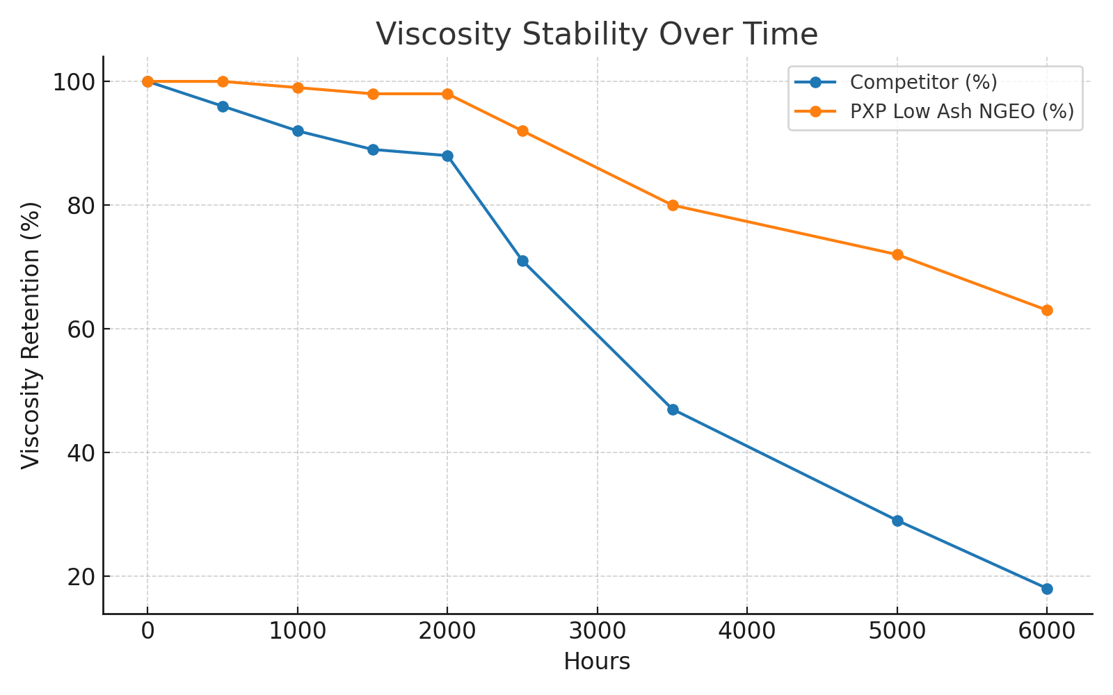
Figure 1: Viscosity Stability Over Time — PXP Low Ash NGEO maintains viscosity far better than competitor oils over extended service hours.
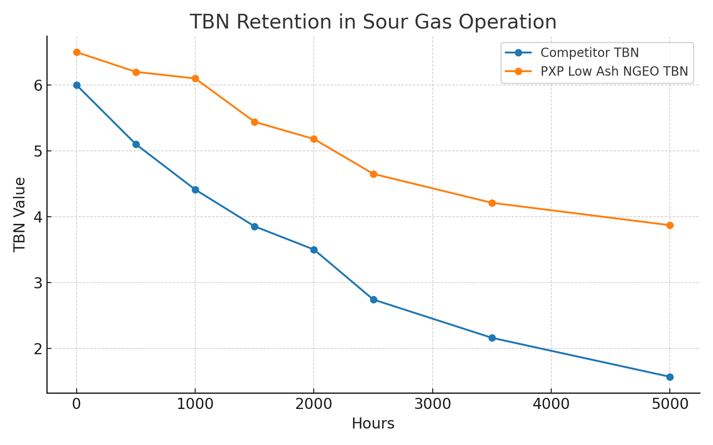
Figure 2: TBN Retention — PXP Low Ash NGEO demonstrates superior acid neutralizing capacity retention in sour gas service.
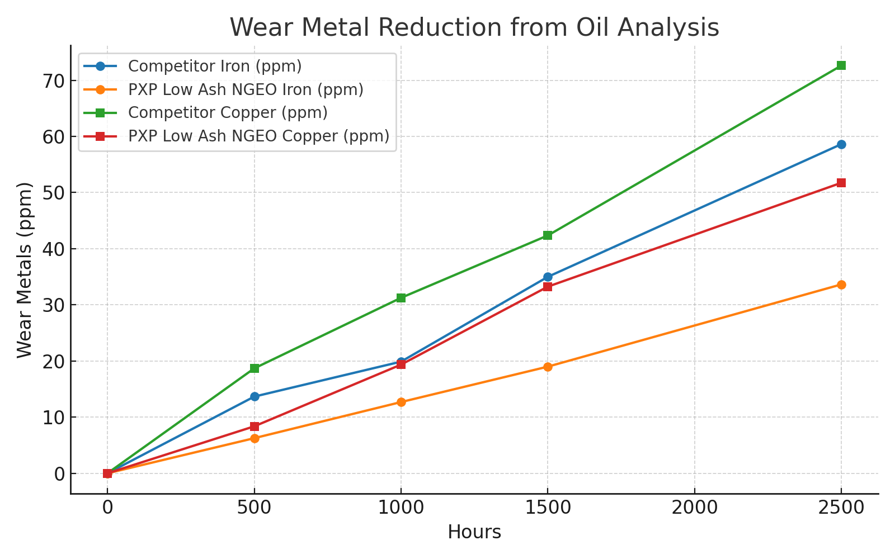
Figure 3: Wear Metal Reduction — PXP Low Ash NGEO significantly reduces iron and copper wear metal accumulation over time.

4. Economic and Operational Impact
By retaining viscosity, maintaining TBN, and reducing wear metals, PXP Low Ash NGEO extends drain intervals, reduces maintenance frequency, and protects high-value engine components. Operators experience lower total cost of ownership, increased uptime, and improved reliability in continuous-duty sour gas compression applications.

5. Conclusion
PXP™ Low Ash NGEO provides a quantifiable advantage over industry norms in high-temperature, continuous-duty sour gas compressor service. Its unique PXP™ Charged™ additive chemistry, synthetic base oil stability, and superior detergent package deliver unmatched protection and longevity, making it the optimal choice for operators seeking maximum return on their lubrication investment.

